MySQL SQL
- Table = Entity
- Columns = Attributes
- Rows = Records/Tuples
- Keys = Special attributes used to identify records uniquely
What is SQL?
- SQL is the standard language for dealing with Relational Databases.
- SQL is used to insert, search, update, and delete database records.
Keep in Mind That...
- SQL keywords are NOT case sensitive: select is the same as SELECT
Semicolon after SQL Statements?
- Some database systems require a semicolon at the end of each SQL statement.
- Semicolon is the standard way to separate each SQL statement in database systems that allow more than one SQL statement to be executed in the same call to the server.
Row and Column
• A row is a horizontal arrangement of data moving from right to left. It is often referred to as a record or a tuple. It represents individual data entries.
• A column is a vertical arrangement of data moving from top to bottom. It is often referred to as an attribute or a field. It represents the characteristics or properties of the data.
SQL Data Types
• Data Types define the type of data that can be stored in a table column.
• It ensures data integrity and optimizes storage. Commonly used Data Types areA. String Datatypes- It stores text strings.
1. CHAR-
• Can store characters of fixed length.
• The size parameter specifies the column length in characters can be from 0 to 255.
2. VARCHAR-
• Can store characters up to given length.
• The size parameter specifies the maximum column length in characters can be from 0 to 65535.
B. Numeric Datatypes- These datatypes store numbers, both integer and floating-point number.
1. INT-
• Used for storing whole numbers without decimal.
2. FLOAT-
• Used for storing numbers without decimal.
• Float gives approximate value while performing calculations.
3. Decimal (P, S)-
• Used to store numbers with a fixed number of decimal places.
• Decimal gives exact value.
• Total range of digits can be 1-38. (Precision-P)
• Range after decimal should be 0-30. (Scale-S)
C. Date and Time Datatypes- These datatypes stores date and time.
• DATE- Stores date values (Format:- YYYY-MM-DD).
• TIME- Stores time values (Format:- HH:MM:SS).
• DATETIME- Stores both date and time values (Format:- YYYY-MM-DD HH:MM:SS).
D. BIT Datatype- BIT data type can store either True or False values (represents by 1 and 0). Example
CREATE TABLE Employees (
EmployeeID INT,
FirstName VARCHAR(50),
LastName CHAR(20),
Salary DECIMAL(10, 2),
BirthDate DATE,
HireTime TIME,
IsActive BIT
);
📌 Relational Database Mapping
Concept | Database Term | Example in Student Table
Entity | Table | Student
Attribute | Column | ID, Name, Grade
Tuple / Record | Row | (101, 'Rahul', 'A')
Primary Key | Unique identifier attribute(s) | ID (e.g., 101)
Foreign Key | Attribute that links to another entity | Marks.StudentID → Student.ID
Domain | Allowed set of values for an attribute | Grade ∈ {A, B, C, D, F}
SQL Commands
• SQL commands are instructions.
• It is used to communicate with the database to perform tasks, functions and queries of data.
• There are five types of SQL commands.
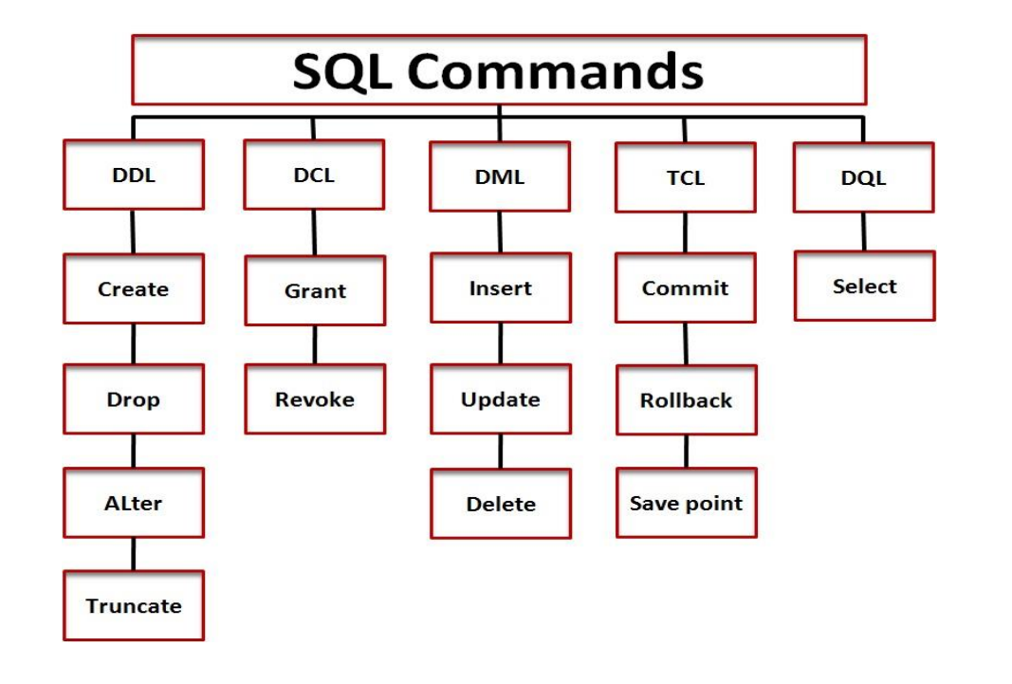
1. Data Definition Language (DDL) - DDL commands are used to define and manage the structure or schema of a database.
2. Data Manipulation Language(DML) - DML commands are used to manipulate or manage the data stored in a database. These commands are specifically designed to modify the actual data stored in the database.
3. Data Control Language(DCL) - DCL commands are specifically designed for managing security and permissions within a database.
4. Transaction Control Language(TCL) - TCL commands manages transactions in a database.
5. Data Query Language(DQL) - DQL commands are used primarily for querying and retrieving data from a database.

📌 MySQL Commands for Interview Preparation
No. | Command | Category
Database Commands
1 | CREATE DATABASE | Core
2 | DROP DATABASE | Core
3 | USE | Core
4 | SHOW DATABASES | Core
5 | SHOW TABLES | Core
Table Definition – DDL
6 | CREATE TABLE | Core
7 | DROP TABLE | Core
8 | ALTER TABLE ADD | Core
9 | ALTER TABLE DROP COLUMN | Core
10 | ALTER TABLE MODIFY | Core
11 | ALTER TABLE RENAME | Core
12 | TRUNCATE TABLE | Core
13 | DESCRIBE / DESC | Core
14 | SHOW CREATE TABLE | Intermediate
Data Manipulation – DML
15 | INSERT INTO VALUES | Core
16 | INSERT INTO (specific cols) | Core
17 | UPDATE | Core
18 | DELETE | Core
Querying Data – DQL
19 | SELECT * | Core
20 | SELECT specific cols | Core
21 | SELECT DISTINCT | Core
22 | SELECT … WHERE | Core
23 | SELECT … ORDER BY | Core
24 | SELECT … LIMIT n | Core
25 | SELECT … LIMIT offset, n | Core
26 | GROUP BY | Core
27 | HAVING | Core
28 | INNER JOIN | Core
29 | LEFT JOIN | Core
30 | RIGHT JOIN | Core
31 | CROSS JOIN | Intermediate
Constraints
32 | PRIMARY KEY | Core
33 | FOREIGN KEY | Core
34 | UNIQUE | Core
35 | CHECK | Core
36 | DEFAULT | Core
37 | NOT NULL | Core
Indexes
38 | CREATE INDEX | Intermediate
39 | CREATE UNIQUE INDEX | Intermediate
40 | DROP INDEX | Intermediate
41 | SHOW INDEX | Intermediate
Views
42 | CREATE VIEW | Intermediate
43 | DROP VIEW | Intermediate
44 | SHOW FULL TABLES (views) | Intermediate
Stored Programs
45 | DELIMITER | Advanced
46 | CREATE PROCEDURE | Advanced
47 | CALL | Advanced
48 | CREATE FUNCTION | Advanced
49 | CREATE TRIGGER | Advanced
50 | DROP PROCEDURE | Advanced
51 | DROP FUNCTION | Advanced
52 | DROP TRIGGER | Advanced
Transaction Control – TCL
53 | START TRANSACTION | Intermediate
54 | SAVEPOINT | Intermediate
55 | ROLLBACK TO | Intermediate
56 | ROLLBACK | Core
57 | COMMIT | Core
58 | SET AUTOCOMMIT | Intermediate
User & Privileges – DCL
59 | CREATE USER | Advanced
60 | DROP USER | Advanced
61 | GRANT | Advanced
62 | REVOKE | Advanced
63 | SHOW GRANTS | Advanced
64 | FLUSH PRIVILEGES | Advanced
Other Utilities
65 | EXPLAIN | Advanced
66 | ANALYZE TABLE | Advanced
67 | OPTIMIZE TABLE | Advanced
68 | SHOW PROCESSLIST / KILL / SHOW VARIABLES | Advanced

🔹 MySQL Commands List
📌 1. Database Commands (5)
- CREATE DATABASE dbname;
- DROP DATABASE dbname;
- USE dbname;
- SHOW DATABASES;
- SHOW TABLES;

📌 2. Table Definition – DDL (9)
- CREATE TABLE table_name (...);
- DROP TABLE table_name;
- ALTER TABLE table_name ADD column datatype;
- ALTER TABLE table_name DROP COLUMN column;
- ALTER TABLE table_name MODIFY column datatype;
- ALTER TABLE table_name RENAME TO new_name;
- TRUNCATE TABLE table_name;
- DESCRIBE table_name; / DESC table_name;
- SHOW CREATE TABLE table_name;

📌 3. Data Manipulation – DML (4)
- INSERT INTO table_name VALUES (...);
- INSERT INTO table_name (col1, col2) VALUES (...);
- UPDATE table_name SET col=value WHERE condition;
- DELETE FROM table_name WHERE condition;

📌 4. Querying Data – DQL (11)
- SELECT * FROM table_name;
- SELECT col1, col2 FROM table_name;
- SELECT DISTINCT col FROM table_name;
- SELECT ... FROM ... WHERE condition;
- SELECT ... FROM ... ORDER BY col ASC/DESC;
- SELECT ... FROM ... LIMIT n;
- SELECT ... FROM ... LIMIT offset, n;
- SELECT col1, COUNT(*) FROM table GROUP BY col1;
- SELECT col1, AVG(col2) FROM table GROUP BY col1 HAVING AVG(col2) > 10;
- SELECT ... FROM t1 INNER JOIN t2 ON condition;
- SELECT ... FROM t1 LEFT JOIN t2 ON condition;
- SELECT ... FROM t1 RIGHT JOIN t2 ON condition;
- SELECT ... FROM t1 CROSS JOIN t2;

📌 5. Constraints (6)
- PRIMARY KEY
- FOREIGN KEY
- UNIQUE
- CHECK (condition)
- DEFAULT value
- NOT NULL

📌 6. Indexes (4)
- CREATE INDEX idx_name ON table(col);
- CREATE UNIQUE INDEX idx_name ON table(col);
- DROP INDEX idx_name ON table;
- SHOW INDEX FROM table_name;

📌 7. Views (3)
- CREATE VIEW view_name AS SELECT ...;
- DROP VIEW view_name;
- SHOW FULL TABLES WHERE Table_type = 'VIEW';

📌 8. Stored Programs (8)
- DELIMITER //
- CREATE PROCEDURE proc_name (...) BEGIN ... END;
- CALL proc_name(...);
- CREATE FUNCTION func_name(...) RETURNS datatype BEGIN ... END;
- CREATE TRIGGER trig_name BEFORE/AFTER INSERT/UPDATE/DELETE ON table FOR EACH ROW ...;
- DROP PROCEDURE proc_name;
- DROP FUNCTION func_name;
- DROP TRIGGER trig_name;

📌 9. Transaction Control – TCL (6)
- START TRANSACTION;
- SAVEPOINT name;
- ROLLBACK TO name;
- ROLLBACK;
- COMMIT;
- SET AUTOCOMMIT = 0/1;

📌 10. User & Privileges – DCL (6)
- CREATE USER 'user'@'localhost' IDENTIFIED BY 'password';
- DROP USER 'user'@'localhost';
- GRANT ALL PRIVILEGES ON db.* TO 'user'@'localhost';
- REVOKE ALL PRIVILEGES ON db.* FROM 'user'@'localhost';
- SHOW GRANTS FOR 'user'@'localhost';
- FLUSH PRIVILEGES;

📌 11. Other Utility Commands (4)
- EXPLAIN SELECT ...;
- ANALYZE TABLE table_name;
- OPTIMIZE TABLE table_name;
- SHOW PROCESSLIST; / KILL process_id; / SHOW VARIABLES; / SHOW STATUS;

Step 1: Create a Database
CREATE DATABASE StudentDB;
USE StudentDB;
Step 2: Create a Table
CREATE TABLE Student (
Id INT,
Name VARCHAR(50),
Grade CHAR(1)
);
Check table structure:
DESCRIBE Student;
Step 3: Insert Data
INSERT INTO Student (Id, Name, Grade) VALUES (1, 'Krishna', 'A');
INSERT INTO Student (Id, Name, Grade) VALUES (2, 'Ravi', 'B');
INSERT INTO Student (Id, Name, Grade) VALUES (3, 'Anjali', 'A');
Step 4: Query Data
- Get all students:
SELECT * FROM Student;
Step 5: Update Data
- Change Ravi’s grade to A+:
UPDATE Student SET Grade='A+' WHERE Name='Ravi';
Step 6: Delete Data
- Remove a student:
DELETE FROM Student WHERE Id=3;
Step 7: Useful Commands
1. List all tables:
SHOW TABLES;
2. See table structure:
DESCRIBE Student;
3. Drop table (if needed):
DROP TABLE Student;
4. Drop database (if needed):
DROP DATABASE StudentDB;
1. Advanced SELECT Queries

2. Sorting: ORDER BY
- ORDER BY sorts rows in ascending (ASC) or descending (DESC) order.
- Default is ASC.
Mini Exercises:
- Sort students by Id descending.
Code:- SELECT * FROM student ORDER BY name ASC;
- Sort students by Grade and then by Id.
Code:- SELECT * FROM student ORDER BY grade ASC, id ASC;
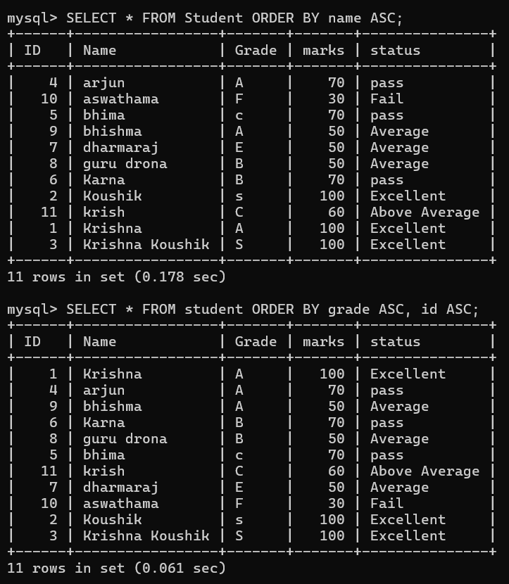
LIMIT:
LIMIT restricts the number of rows returned.
Mini Exercises:
- Get the first 3 students.
Code:- SELECT * FROM student LIMIT 0,3;
- Skip the first student and get the next 2.
Code:- SELECT * FROM student LIMIT 1,2;
OUTPUT:-
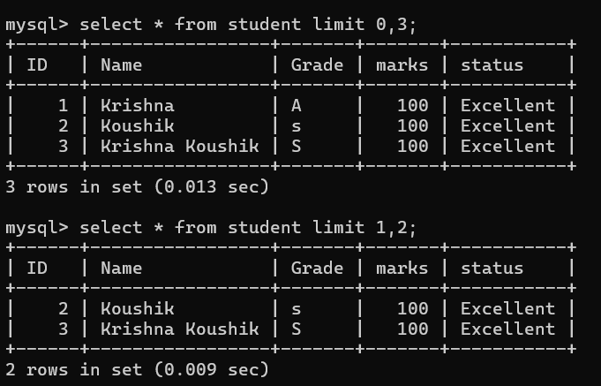
4. Pattern Matching: LIKE and Wildcards
- % → matches any number of characters
- _ → matches exactly one character
Mini Exercises:
- Select students whose name contains 'a'.
Code:- SELECT * FROM student WHERE name LIKE ‘%a’;
- Select students whose name ends with 'a'.
Code:- SELECT * FROM student WHERE name LIKE ‘%a’;
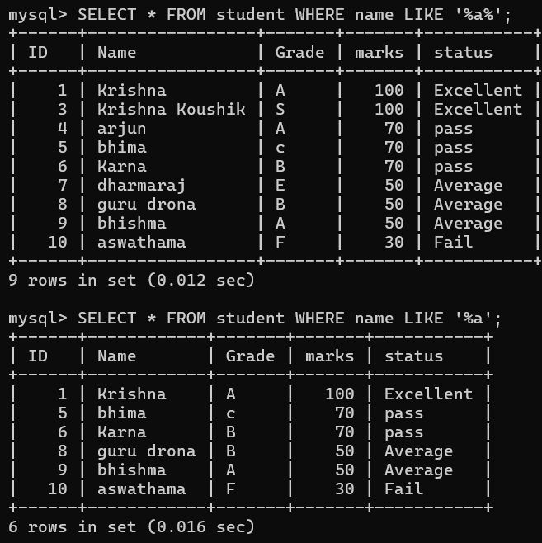

5. Aggregate Functions
- COUNT() → count row → SELECT COUNT(*) FROM student;
- SUM() → sum of values → SELECT SUM(name) FROM student;
- AVG() → average of values → SELECT AVG(marks) FROM student;
- MIN() → smallest value → SELECT MIN(marks) FROM student;
- MAX() → largest value → SELECT MAX(marks) FROM student;
Mini Exercises:
- Count how many students have grade 'A'.
Code:- SELECT COUNT(grade=’A’) FROM student;
- Find the average Id.
Code:- SELECT AVG(id) FROM student;

